DESIGNING PROFESSIONAL BUSINESS CARDS

INTRODUCATION

* 1. Overview
* **Find a template that reflects your brand’s personality.**
* **Find the right typeface.**
* **Settle on a size and shape.**
* **Organize your information.**
* **Do double duty.**

**Purpose :**

**They say you never get a second chance to make a first impression ,and nowhere does this ring more true than in the world of networking.**

**Business cards have been around for centuries – in fact , the origins of the humble 85mm x 55mm rectangle of card can be traced back to the 15m century, where the upper class would use them calling cards to announce an intention to meet another individual.**

**PROPLEM DEFINITATION &DESIGNING THINKING:**

2.1 Empathy Map

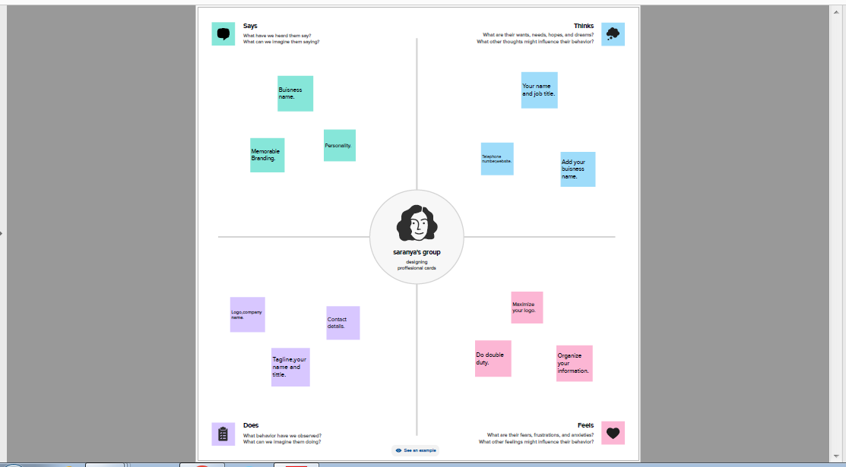

2.2 Brainstorming

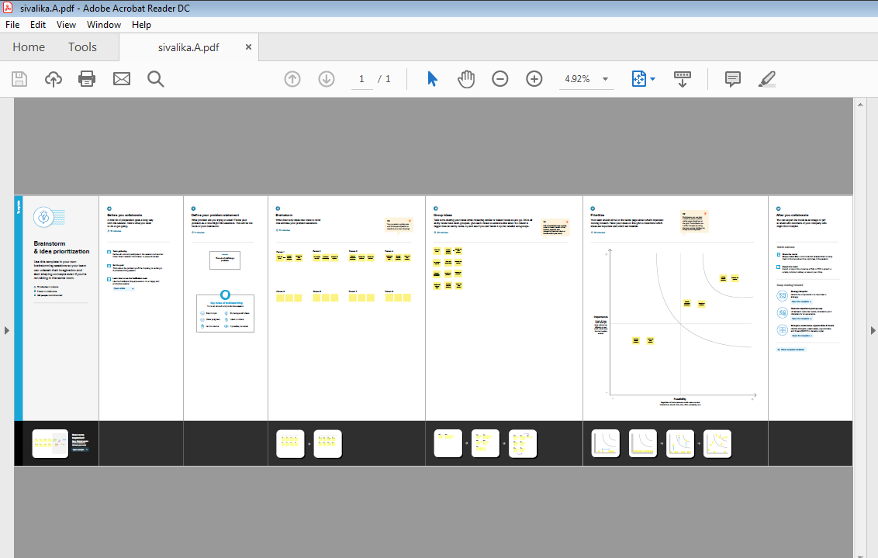

Result:

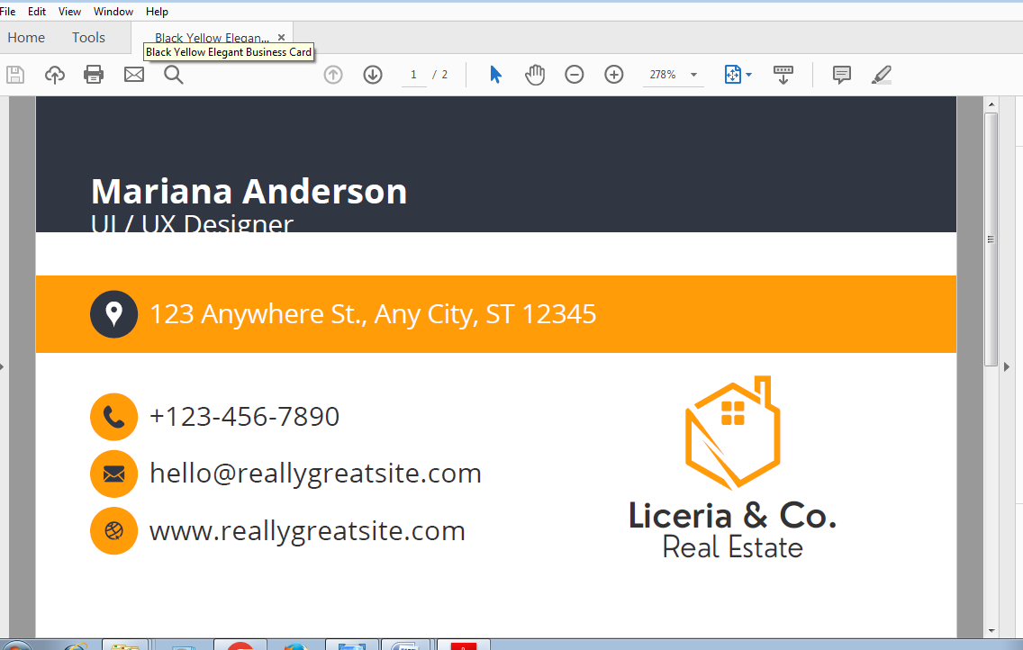

4. ADVANTAGES AND DISADVANTAGES

ADVANTAGE:

* Affordable Advertisement
* Perfect For Events
* Tangible
* Easy Distribution
* People WON’T Forget Your Email

DISADVANTAGE:

* High Rate of Interest
* Deception
* Hidden Costs
* Restricted Drawings
* Minimum Due

5. APPLICATION

Your business card should give customers everything they need to contact you, find you online, or locate your storefront . Aside from your name and job title, add your business name, telephone number, website ,email address, and applications of a business card

6. CONCLUSION

Digital business cards offer businesses and individuals a convenient and cost-effective way to save money when networking.